**Create a Spring Web Project using Maven**

1. Go to <https://start.spring.io/>

2. Change Group as “com.cognizant”

3. Change Artifact Id as “spring-learn”

4. Select Spring Boot DevTools and Spring Web

5. Create and download the project as zip

6. Extract the zip in root folder to Eclipse Workspace

7. Build the project using ‘mvn clean package -Dhttp.proxyHost=proxy.cognizant.com -Dhttp.proxyPort=6050 -Dhttps.proxyHost=proxy.cognizant.com -Dhttps.proxyPort=6050 -Dhttp.proxyUser=123456’ command in command line

8. Import the project in Eclipse "File > Import > Maven > Existing Maven Projects > Click Browse and select extracted folder > Finish"

**9. Include logs to verify if main() method of SpringLearnApplication.**

**10. Run the SpringLearnApplication class.**

Add Logging to SpringLearnApplication.java

package com.cognizant.spring_learn;

import org.springframework.boot.SpringApplication;

import org.springframework.boot.autoconfigure.SpringBootApplication;

import org.slf4j.Logger;

import org.slf4j.LoggerFactory;

@SpringBootApplication

public class SpringLearnApplication {

private static final Logger LOGGER = LoggerFactory.getLogger(SpringLearnApplication.class);

public static void main(String[] args) {

LOGGER.info("STARTING SpringLearnApplication...");

SpringApplication.run(SpringLearnApplication.class, args);

LOGGER.info("SpringLearnApplication STARTED successfully.");

}

}

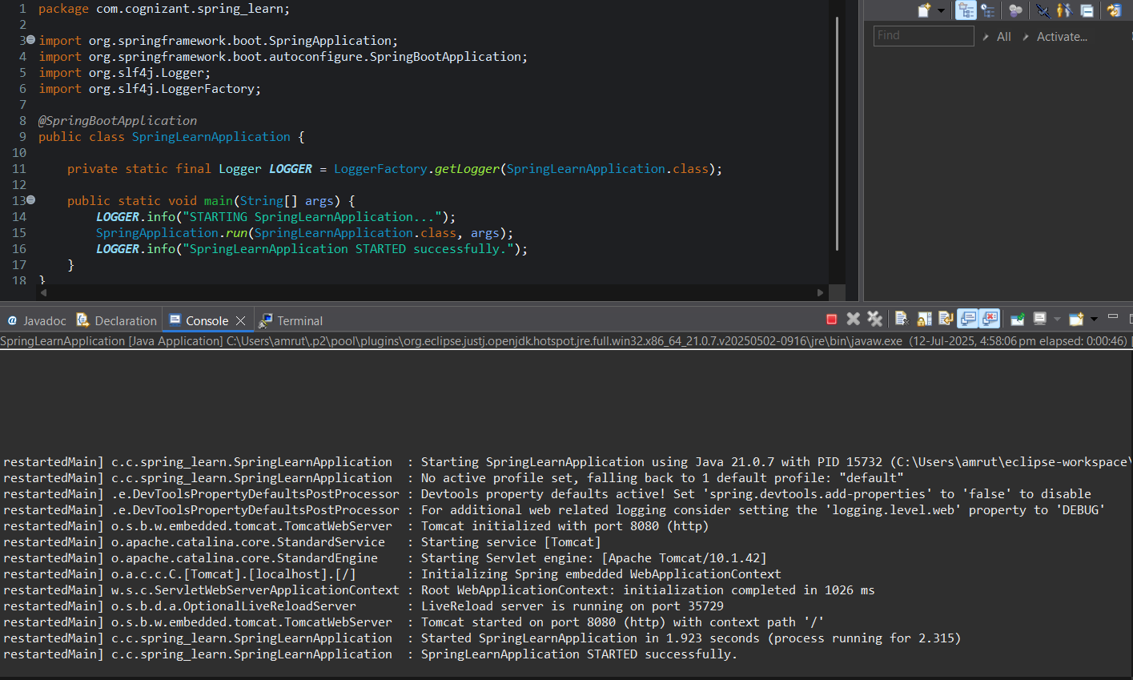

**2. Spring Core – Load Country from Spring Configuration XML**

package com.cognizant.spring_learn;

import org.slf4j.Logger;

import org.slf4j.LoggerFactory;

import org.springframework.boot.SpringApplication;

import org.springframework.boot.autoconfigure.SpringBootApplication;

import org.springframework.context.ApplicationContext;

import org.springframework.context.support.ClassPathXmlApplicationContext;

@SpringBootApplication

public class SpringLearnApplication {

private static final Logger LOGGER = LoggerFactory.getLogger(SpringLearnApplication.class);

public static void main(String[] args) {

SpringApplication.run(SpringLearnApplication.class, args);

displayCountry();

}

public static void displayCountry() {

ApplicationContext context = new ClassPathXmlApplicationContext("country.xml");

Country country = context.getBean("country", Country.class);

LOGGER.debug("Country : {}", country.toString());

}

}

**Coutry.xml**

<?xml version="1.0" encoding="UTF-8"?>

<beans xmlns="http://www.springframework.org/schema/beans"

xmlns:xsi="http://www.w3.org/2001/XMLSchema-instance"

xsi:schemaLocation="

http://www.springframework.org/schema/beans

http://www.springframework.org/schema/beans/spring-beans.xsd">

<bean id="country" class="com.cognizant.spring_learn.Country">

<property name="code" value="IN"/>

<property name="name" value="India"/>

</bean>

</beans>

<?xml version="1.0" encoding="UTF-8"?>

<beans xmlns="http://www.springframework.org/schema/beans"

xmlns:xsi="http://www.w3.org/2001/XMLSchema-instance"

xsi:schemaLocation="

<http://www.springframework.org/schema/beans>

<http://www.springframework.org/schema/beans/spring-beans.xsd>">

<bean id="country" class="com.cognizant.spring_learn.Country">

<property name="code" value="IN"/>

<property name="name" value="India"/>

</bean>

</beans>

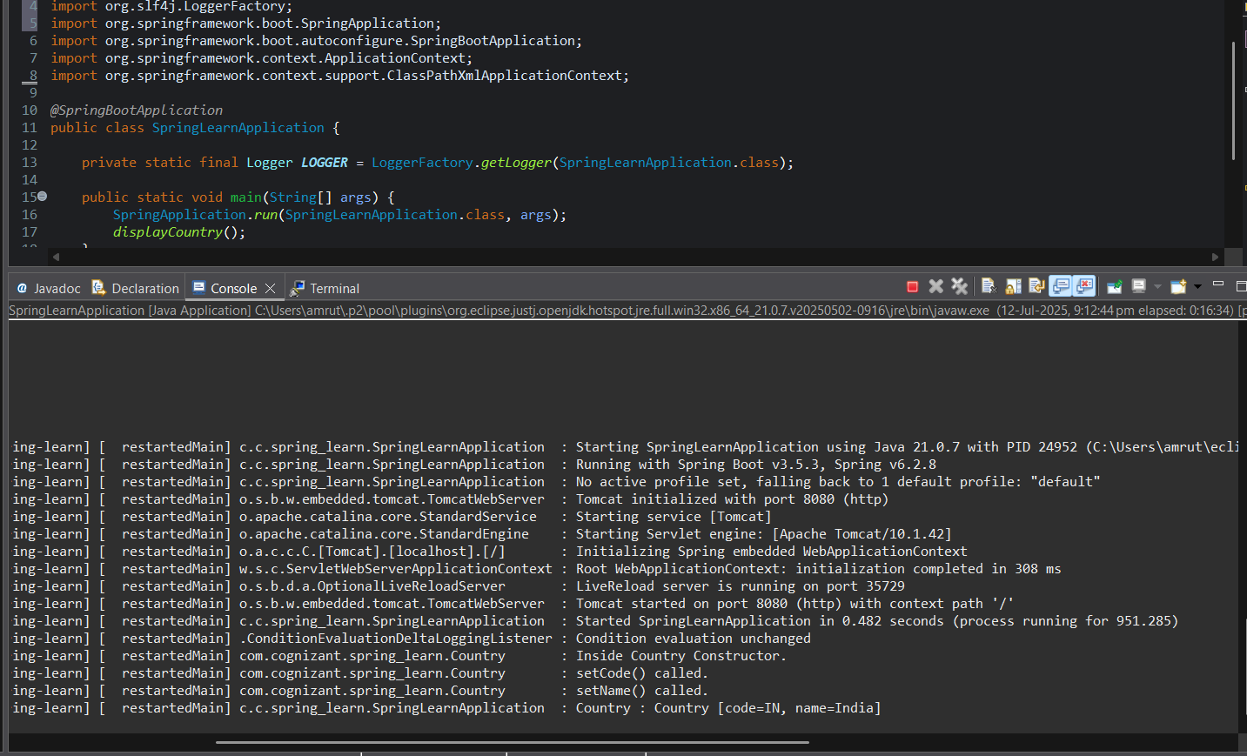

**3.Hello World RESTful Web Service**

HelloController.java:

package com.cognizant.spring_learn.controller;

import org.slf4j.Logger;

import org.slf4j.LoggerFactory;

import org.springframework.web.bind.annotation.GetMapping;

import org.springframework.web.bind.annotation.RestController;

@RestController

public class HelloController {

private static final Logger LOGGER = LoggerFactory.getLogger(HelloController.class);

@GetMapping("/hello")

public String sayHello() {

LOGGER.info("START - sayHello()");

String message = "Hello World!!";

LOGGER.info("END - sayHello()");

return message;

}

}

application.properties:

server.port=8083

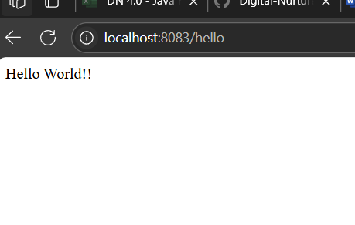

**4. REST - Country Web Service**

**CountryController.java**

package com.cognizant.spring_learn.controller;

import com.cognizant.spring_learn.Country;

import org.slf4j.Logger;

import org.slf4j.LoggerFactory;

import org.springframework.context.ApplicationContext;

import org.springframework.context.support.ClassPathXmlApplicationContext;

import org.springframework.web.bind.annotation.RequestMapping;

import org.springframework.web.bind.annotation.RestController;

@RestController

public class CountryController {

private static final Logger LOGGER = LoggerFactory.getLogger(CountryController.class);

@RequestMapping("/country")

public Country getCountryIndia() {

LOGGER.info("START - getCountryIndia()");

ApplicationContext context = new ClassPathXmlApplicationContext("country.xml");

Country country = context.getBean("country", Country.class);

LOGGER.info("END - getCountryIndia()");

return country;

}

}

http://localhost:8083/country

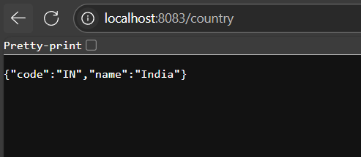

**5. REST - Get country based on country code**

Country.xml

<?xml version="1.0" encoding="UTF-8"?>

<beans xmlns="http://www.springframework.org/schema/beans"

xmlns:xsi="http://www.w3.org/2001/XMLSchema-instance"

xsi:schemaLocation="

http://www.springframework.org/schema/beans

http://www.springframework.org/schema/beans/spring-beans.xsd">

<bean id="country" class="com.cognizant.spring_learn.Country">

<property name="code" value="IN"/>

<property name="name" value="India"/>

</bean>

<bean id="countryList" class="java.util.ArrayList">

<constructor-arg>

<list>

<bean class="com.cognizant.spring_learn.Country">

<property name="code" value="IN"/>

<property name="name" value="India"/>

</bean>

<bean class="com.cognizant.spring_learn.Country">

<property name="code" value="US"/>

<property name="name" value="United States"/>

</bean>

<bean class="com.cognizant.spring_learn.Country">

<property name="code" value="DE"/>

<property name="name" value="Germany"/>

</bean>

<bean class="com.cognizant.spring_learn.Country">

<property name="code" value="JP"/>

<property name="name" value="Japan"/>

</bean>

</list>

</constructor-arg>

</bean>

</beans>

**CountryService.java**

package com.cognizant.spring_learn.service;

import com.cognizant.spring_learn.Country;

import org.springframework.context.ApplicationContext;

import org.springframework.context.support.ClassPathXmlApplicationContext;

import org.springframework.stereotype.Service;

import java.util.List;

@Service

public class CountryService {

public Country getCountry(String code) {

ApplicationContext context = new ClassPathXmlApplicationContext("country.xml");

List<Country> countries = context.getBean("countryList", List.class);

// Lambda expression for case-insensitive search

return countries.stream()

.filter(c -> c.getCode().equalsIgnoreCase(code))

.findFirst()

.orElse(null); // or throw a custom exception

}

}

Update the Controller

package com.cognizant.spring_learn.controller;

import com.cognizant.spring_learn.Country;

import com.cognizant.spring_learn.service.CountryService;

import org.slf4j.Logger;

import org.slf4j.LoggerFactory;

import org.springframework.beans.factory.annotation.Autowired;

import org.springframework.web.bind.annotation.*;

@RestController

public class CountryController {

private static final Logger LOGGER = LoggerFactory.getLogger(CountryController.class);

@Autowired

private CountryService countryService;

@GetMapping("/countries/{code}")

public Country getCountry(@PathVariable String code) {

LOGGER.info("START - getCountry()");

Country country = countryService.getCountry(code);

LOGGER.info("END - getCountry()");

return country;

}

}

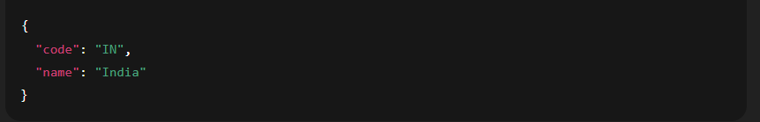

**6. Create authentication service that returns JWT**

pom.xml:

<dependency>  
 <groupId>io.jsonwebtoken</groupId>  
 <artifactId>jjwt</artifactId>  
 <version>0.9.1</version>  
</dependency>  
<dependency>  
 <groupId>org.springframework.boot</groupId>  
 <artifactId>spring-boot-starter-security</artifactId>  
</dependency>

JwtUtil.java

package com.cognizant.spring_learn.util;  
  
import io.jsonwebtoken.Jwts;  
import io.jsonwebtoken.SignatureAlgorithm;  
import org.springframework.stereotype.Component;  
  
import java.util.Date;  
  
@Component  
public class JwtUtil {  
 private static final String SECRET_KEY = "mysecretkey"; // use env var in production  
  
 public String generateToken(String username) {  
 return Jwts.builder()  
 .setSubject(username)  
 .setIssuedAt(new Date(System.currentTimeMillis()))  
 .setExpiration(new Date(System.currentTimeMillis() + 1000 * 60 * 10)) // 10 mins  
 .signWith(SignatureAlgorithm.HS256, SECRET_KEY)  
 .compact();  
 }  
}

AuthenticationController.java

package com.cognizant.spring_learn.controller;  
  
import com.cognizant.spring_learn.util.JwtUtil;  
import org.springframework.beans.factory.annotation.Autowired;  
import org.springframework.http.*;  
import org.springframework.web.bind.annotation.*;  
  
import java.util.Base64;  
  
@RestController  
public class AuthenticationController {  
  
 @Autowired  
 private JwtUtil jwtUtil;  
  
 @RequestMapping(value = "/authenticate", method = RequestMethod.GET)  
 public ResponseEntity<?> authenticate(@RequestHeader("Authorization") String authHeader) {  
 if (authHeader == null || !authHeader.startsWith("Basic ")) {  
 return new ResponseEntity<>("Missing or invalid Authorization header", HttpStatus.UNAUTHORIZED);  
 }  
  
 // Decode base64 credentials  
 String base64Credentials = authHeader.substring("Basic ".length()).trim();  
 byte[] decodedBytes = Base64.getDecoder().decode(base64Credentials);  
 String decoded = new String(decodedBytes);  
 String[] credentials = decoded.split(":", 2);  
 String username = credentials[0];  
 String password = credentials[1];  
  
 // Validate credentials (replace with real logic)  
 if ("user".equals(username) && "pwd".equals(password)) {  
 String token = jwtUtil.generateToken(username);  
 return ResponseEntity.ok().body("{\"token\":\"" + token + "\"}");  
 } else {  
 return new ResponseEntity<>("Invalid credentials", HttpStatus.UNAUTHORIZED);  
 }  
 }  
}

SecurityConfig.java

package com.cognizant.spring_learn.config;  
  
import org.springframework.context.annotation.Configuration;  
import org.springframework.security.config.annotation.web.builders.HttpSecurity;  
import org.springframework.security.config.annotation.web.configuration.*;  
  
@Configuration  
@EnableWebSecurity  
public class SecurityConfig extends WebSecurityConfigurerAdapter {  
  
 @Override  
 protected void configure(HttpSecurity http) throws Exception {  
 http  
 .csrf().disable() // disable CSRF for curl/postman testing  
 .authorizeRequests()  
 .antMatchers("/authenticate").permitAll()  
 .anyRequest().authenticated();  
 }  
}

